**JAVA SCRIPT DOM**

With the help of DOM we can

1) change/remove html elements in the DOM

2) change/add CSS styles

3) Read and Change element attributes.

Use dom1.html file

We add javascript source file to an html page with the tags:

<script src= “something.js”> </script>

document object is provided by the browser.

document.getElementById(‘id’)

id’s should be unique. If they arent then the browser/js will give unexpected results.

class isnt unique. you can name different sections as same class.

document.getElementByClassName(‘class_name’); will be used.

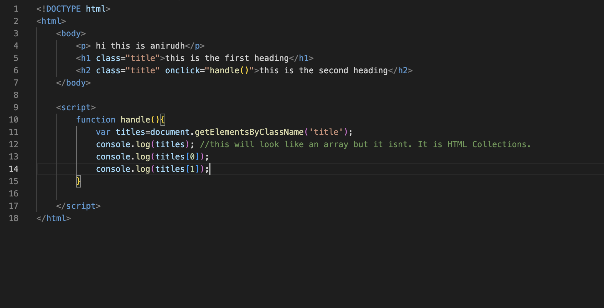

html5 attributes in the tags must be written in all lower case. Some browsers correct the mistakes but some dont. They may lead to errors.

We know how to call elements with iD and Class. We can call with the help of query.

const lol=document.querySelector(‘#the_id_of_the_element’);

However, it returns null if the dom didnt load yet. If the script is called before the dom loads then lol will be null. Hence, call the function after the dom loads.

For query selector use dom2.html and dom2.js